**Diagnostic’s**

**Medical Test**

**Information System**

Version 1.5

 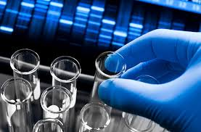



Diagnostic’s

Medical Test Information System

***Submitted By:***

**S. Rayhan Kabir** (**ID: 133-35-561) Section:**

**Jewel Rana (ID: 133-35-558) Section:**

**12th Batch**

***Department of Software Engineering***

**Daffodil International University**

Course Name: **Software Engineering Project-l (using C)**

Course Code: **SWE231**

***Submitted To:***

**Shikha Anirban**

**Senior Lecturer**

Department of Software Engineering

**Daffodil International University**

***Date of Submission:***



***Daffodil International University***

Abstract:

This article is about [medical tests](http://en.wikipedia.org/wiki/Medical_test) for [diagnostics](http://en.wikipedia.org/wiki/Diagnostics). In medicine, a **diagnostic’s medical test** is any kind of [medical test](http://en.wikipedia.org/wiki/Medical_test) performed to aid in the [diagnosis](http://en.wikipedia.org/wiki/Medical_diagnosis) or detection of [disease](http://en.wikipedia.org/wiki/Disease). A [diagnostic test](http://en.wikipedia.org/wiki/Diagnostic_test) is a procedure performed to confirm, or determine the presence of disease in an individual suspected of having the disease, usually following the report of symptoms, or based on the results of other medical tests.

So, we’ve tested this for **Diagnostic Center** and we hope ***“Software of Diagnostic Medical Information System”*** will helpful for collect medical test at any Diagnostic Center. That’s why; we think it will make some revolution to our real life.

Interpretation of diagnostic tests should always take sources of [inaccuracy and imprecision](http://en.wikipedia.org/wiki/Inaccuracy_and_imprecision) into account. Sources of inaccuracy and imprecision of diagnostic tests may broadly be categorized as:

* Physical sources within the diagnostic test taking itself
* Interpretational sources of the resultant data in relation to the target condition. Such sources include conversion of continuous values to binary ones (creating [artificially binary values](http://en.wikipedia.org/wiki/Artificially_binary_value)), such as designating a blood test for [prostate specific antigen](http://en.wikipedia.org/wiki/Prostate_specific_antigen) as "positive" when having reached a certain [cutoff value](http://en.wikipedia.org/wiki/Cutoff_(reference_value)), which is generally less accurate than considering the value itself.

Proper evaluation of a diagnostic test involves the use of [statistical analysis](http://en.wikipedia.org/wiki/Statistics). In this context the test is referred to as a [classification rule](http://en.wikipedia.org/wiki/Classification_rule) for a [binary classifier](http://en.wikipedia.org/wiki/Binary_classification). The test is then compared to a [gold standard test](http://en.wikipedia.org/wiki/Gold_standard_(test)) to assess the quality. Common methods for evaluation involve the [receiver operating characteristic](http://en.wikipedia.org/wiki/Receiver_operating_characteristic), [Matthews correlation coefficient](http://en.wikipedia.org/wiki/Matthews_correlation_coefficient) or [F1 score](http://en.wikipedia.org/wiki/F1_score)but no metric is without bias.

Contents

Introduction 5

Literature review 5

Stakeholdar of the Project 6

Existing System 7

Project Goal 8

Functional Requirements 8

**Non Functional Requirements** **9**

Use Case Diagram 10

Result & Discution 11

Conclusion 14

Reference 14

***Daffodil International University***

# Introduction

## The purpose of this document is to collect, analyze and define the high-level needs and features of the ”Diagnostic’s Medical Test Information System”. It focuses on the capabilities and facilities needed by the stakeholder who are work in Diagnostic Center and target users the Doctors, Receptionist, Director, Chairman etc. of the Diagnostic Center. The details of what all are the needs Diagnostic’s Information *System* fulfils these needs are detailed in the use-case and supplementary specifications.

# Literature Review

The purpose of this document is to describe the collect and include of the information of the Medical Test of the patient. The Document captures high-level requirements and design constraints, which gives the reader an understanding of the Information of Medical Test Handling System of Patients. Requirements Specification defines and describes the operations, interfaces, performance, and quality assurance requirements of the Medical Test Information System. The document also describes the nonfunctional requirements such as the user interfaces. It also describes the design constraints that are to be considered when the system is to be designed.

The *Diagnostic Medical Test Information System* that is to be developed provides the Patient, Doctors, and Worker of the Diagnostic Center with detail information about Medical Test. The System is supposed to have the following features.

* The system provides medical test result or information service to the Patient, Doctor and some worker who are related with work of medical test.
* The system provides the stuffs with the option to check their medical test whenever needed all through the day.

The features that are described in this document are used in the future phases of the software development cycle. The features described here meet the needs of all the users. The success criteria for the system are based in the level up to which the features described in this document are implemented in the system.

This document lists all the capabilities of count the Information and Result of Medical Test in the Diagnostic Center. Diagnostic Center a kind of organization where find medical test of the patient. Diagnostic organization only finds and identifies the medical report or result of patient. The software system is like a spiral system and their service.

# Stakeholder of the Project

The systemthat is to be developed provides the patient, Doctors, Worker of the Diagnostic with medical test information.

**The stakeholders for this system are:**

* Chairman.
* Directors.
* Manager Admin.
* Doctors.
* Medical Technologist.
* Chamist
* Patient.
* Assistant of Doctors or Technologist.
* Receptionist.
* Computer Operator.

# Existing System

There is no automated system for this system. Most diagnostic tests are conducted on the living; however, some of these tests can also be carried out on a dead person as part of an [autopsy](http://en.wikipedia.org/wiki/Autopsy). Some of the diagnostic tests are parts of a simple [physical examination](http://en.wikipedia.org/wiki/Physical_examination) which require only simple tools in the hands of a skilled practitioner, and can be performed in an office environment. Some other tests require elaborate equipment used by [medical technologists](http://en.wikipedia.org/wiki/Medical_technologist) or the use of a sterile operating theatre environment. Some tests require samples of tissue or body fluids to be sent off to a [pathology lab](http://en.wikipedia.org/wiki/Medical_laboratory) for further analysis. Some simple chemical tests, such as [urine](http://en.wikipedia.org/wiki/Urine) [pH](http://en.wikipedia.org/wiki/PH), can be measured directly in the doctor's office.

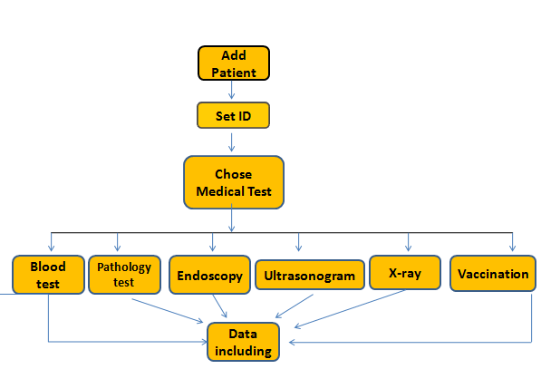

# Project Goal

The medical profession requires the ability to provide diagnostic medical imaging utilizing critical thinking skills to make judgments in the process. Medical professionals who must possess high level skills in diagnostic techniques under the guidance of a licensed physician. A medical software is responsible for providing excellent patient care and gathering adequate data necessary for diagnoses to be determined.

Graduates of the project will be able to perform, at minimum, the following objectives:

* Obtain, review and integrate pertinent patient data to facilitate optimum diagnostic results by software.
* Demonstrate critical thinking skills during the performance of medical procedures to provide optimum diagnostic services in a information system.

## Functional Requirement

1. Add Patient
2. Add Medical Test
3. Blood Test
4. Pathology Test
5. Urine Test
6. Stool Test
7. Endoscopy
8. Ultrasonogram
9. Vaccination
10. X-ray Report
11. View Patient
12. View Medical Test
13. Search Patient
14. Search Medical Test
15. Edit Patient
16. Edit Medical Test
17. Delete Option

## Non Functional Requirement

* Speed = Take a little time to execute the full program.
* Platform compatibility = Can work on any OS (operating environment) like Windows, Linux and Mac with Code Block, Turbo C etc.
* Usability = For being simple and easy coding it becomes understandable to all especially to the students. They can easily able to use this system and got best feedback.
* Backup = This system is till now under processing and for any kind of disaster attack we keep a backup of our system for recovery.
* Quality = It can be used by any level of users of DIU who needs to book bus ticket from DIU. But this system is mostly preferable for the student and members.
* Operation = It can able to save passenger’s information and admin panel data.
* Update = Our system will be updated to v2.0 and more in future.
* Effectiveness = If any one give any input this system quickly execute all the data and give expected result.
* Efficiency = It can work on any platform and it can be handled easily by anyone.
* Extensibility = We can able to add any features and any more option at any time with our system.

## Use Case Diagram

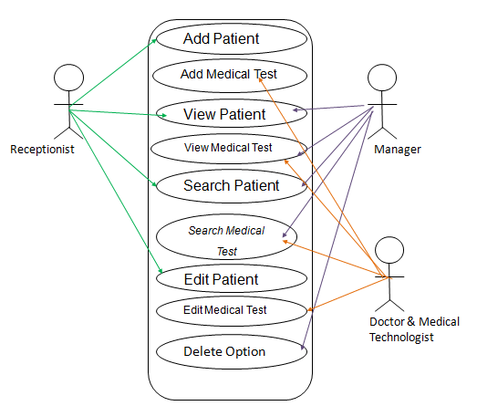

# Result & Discussion

# This is Main Menu

# C:\Users\Rayhan\Desktop\pic of c proj\Capture1.PNG

**This is Add Medical Test**

# C:\Users\Rayhan\Desktop\pic of c proj\Capture2.PNG

# This is Add Pathology Test

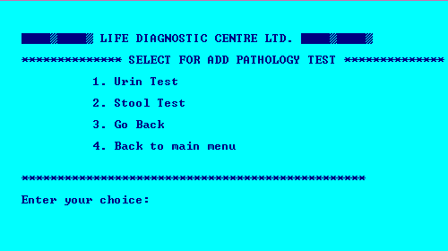

**This is View Medical Test**

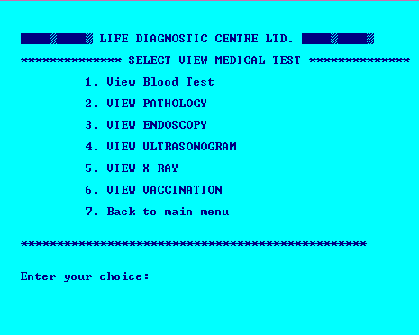

**This is Search Medical Test**

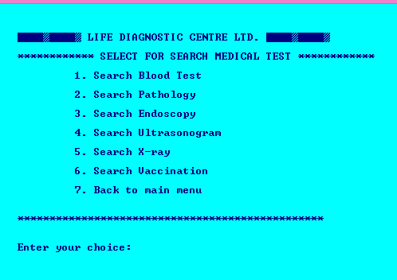

**This is Edit Medical Test**

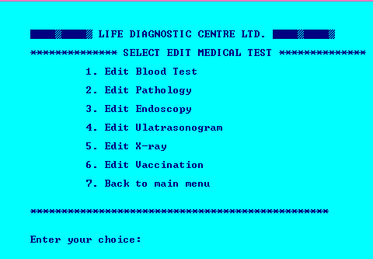

# Conclusion

We believe such system will help to the Diagnostic Center organization for take care the Information of medical test of patient. So A Diagnostic’s Medical Test Information System is a kind of [medical software procedure](http://en.wikipedia.org/wiki/Medical_procedure)  performed to [detect](http://en.wikipedia.org/wiki/Screening_(medicine)), [diagnose](http://en.wikipedia.org/wiki/Medical_diagnosis), or [monitor](http://en.wikipedia.org/wiki/Monitoring_(medicine)) diseases, disease processes, susceptibility, and determine a course of treatment.

# Reference

1. **Vision Documents.**
2. **PUCSD Library Management System.**